1/ remove these 2 screws on both sides to take off the L-shaped holder

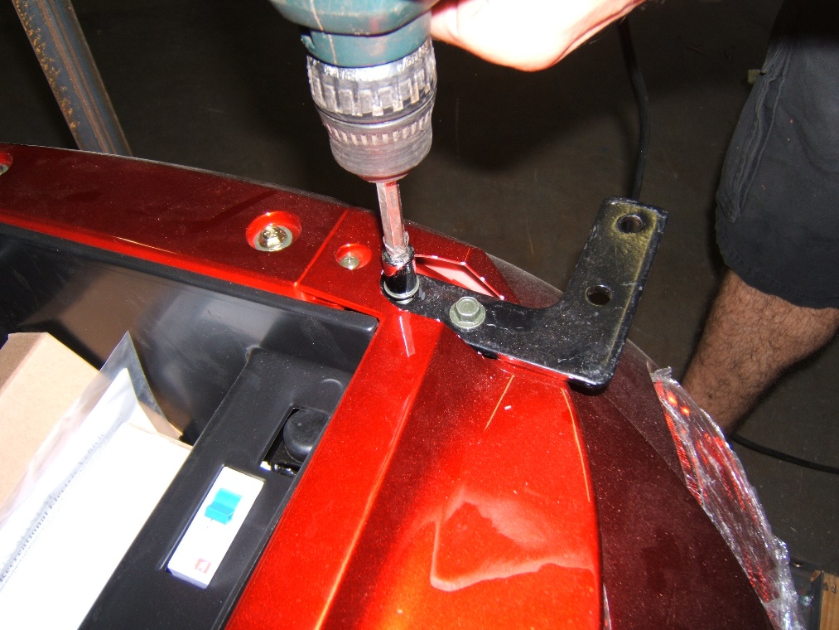

2/ Place the storage box holder on the top of the holder

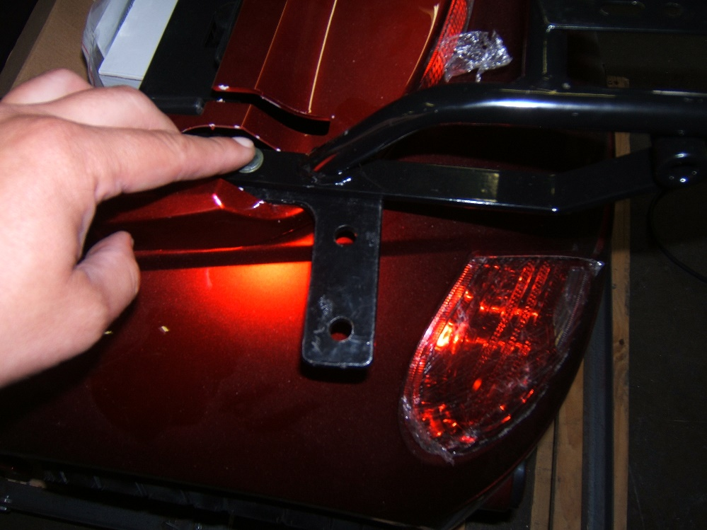

3/ Insert the chrome roof holder through the holes of the L-shaped holder. IT WILL NOT FIT IF YOU TIGHTEN THE SCREWS TOO MUCH SO YOU CANNOT ADJUST THE POSITION OF THE L-SHAPED HOLDER TO MAKE THE ROOF HOLDER FIT!

